|  |  |  |  |  |  |
| --- | --- | --- | --- | --- | --- |
| Date | 23-Nov-22 | | | Tester Name | Mohammad Yusuf |
| Environment | Penfax - Test | | | Login used |  |
| Operating System | Windows | Version: | Update: | | |
| Software Used | Select Software | Version: | Update: | | |
| Select Software | Version: | Update: | | |
| Release version |  | | | | |
| Title |  | | | | |
| Test Type | Regression | | | | |
| Test Scenario |  | | | | |
|  |  | | | | |
| Expected Results |  | | | | |
| Pass/Fail | Select | | | JIRA# | N/A |

Describe your steps with screenshots:

Member is active without any leave

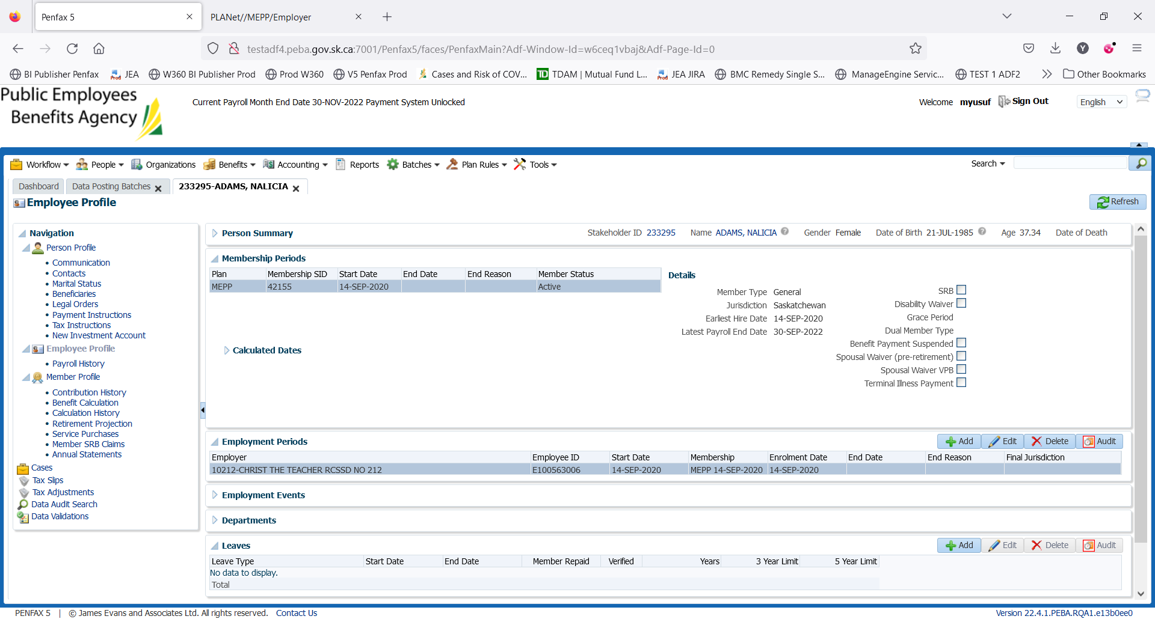

Adding the LOA using DCT . Login into the DCT

Select the correct employer

Click on create New file

Add new file: Leave

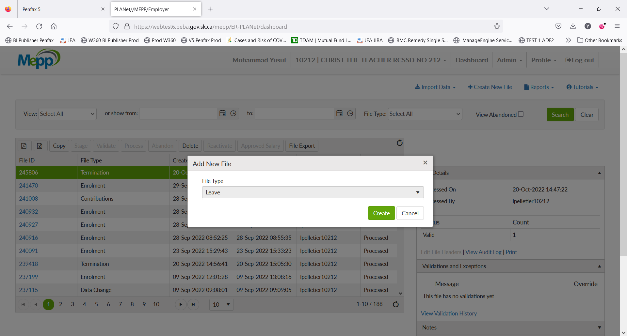

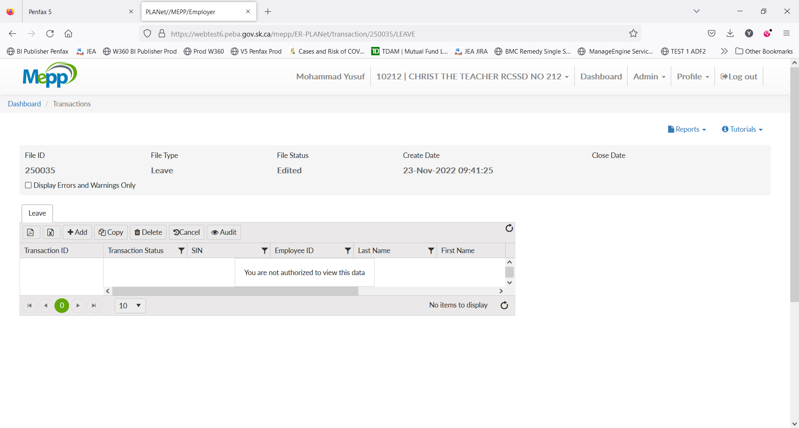

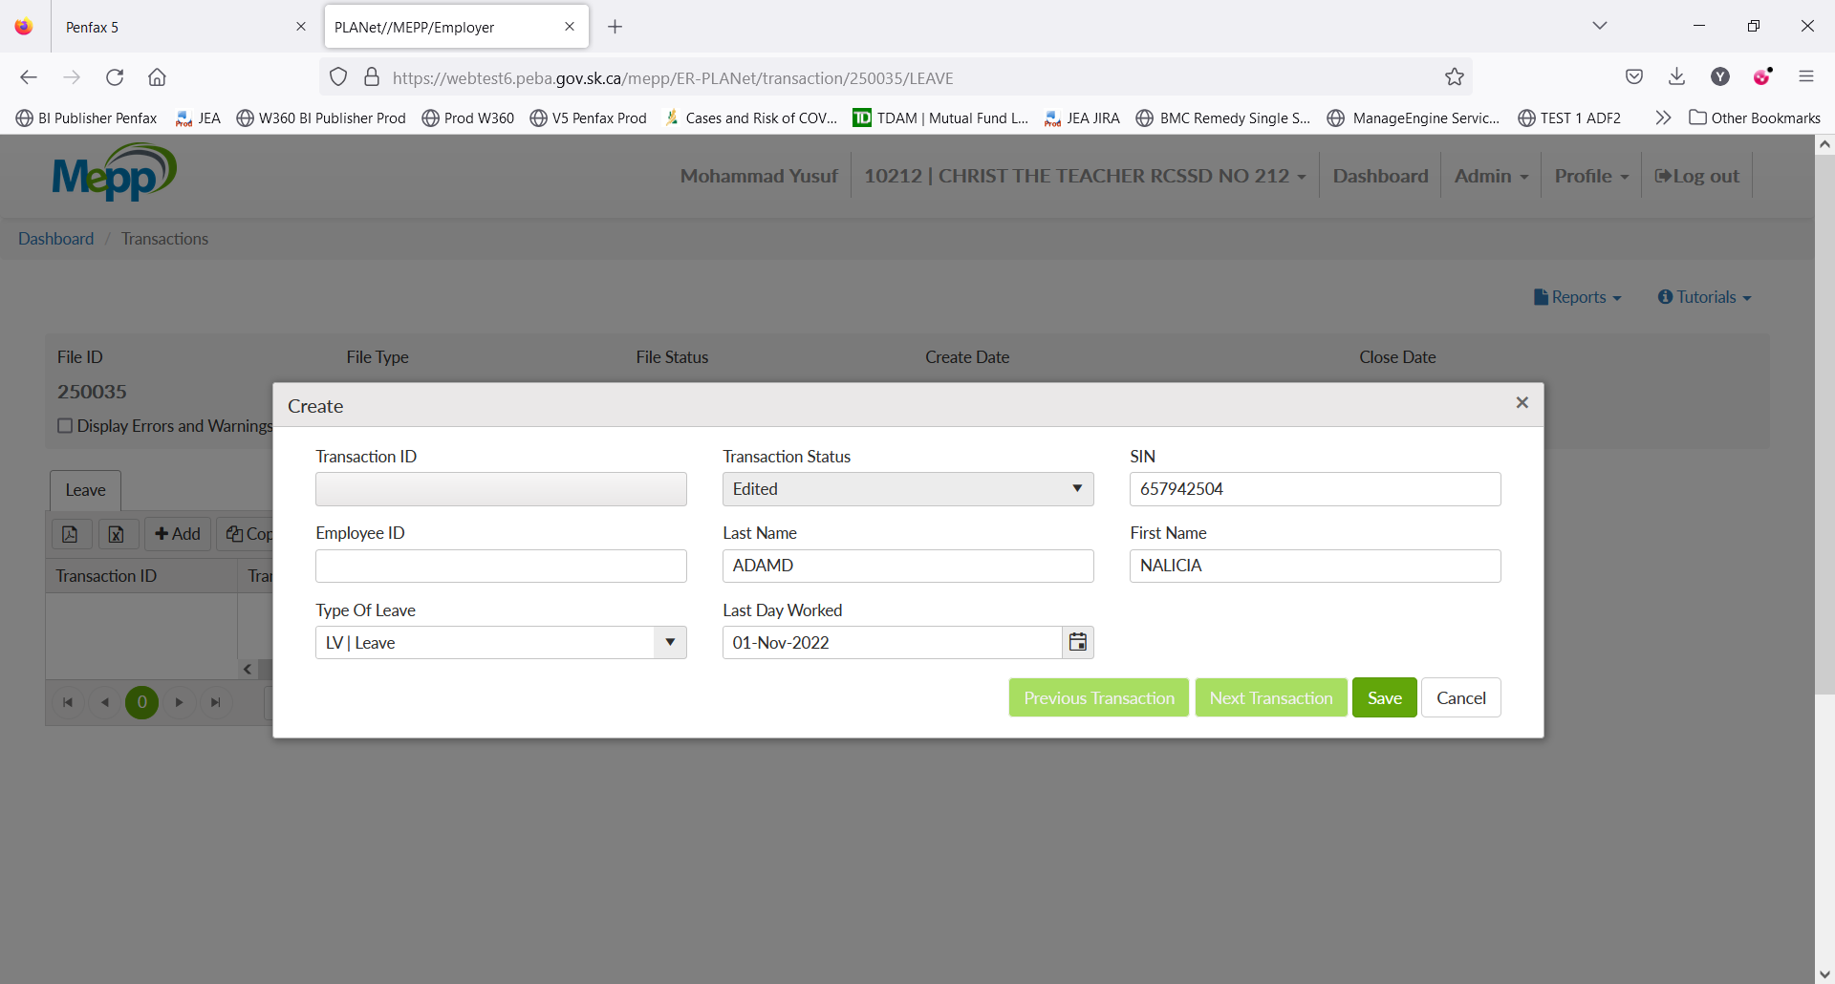

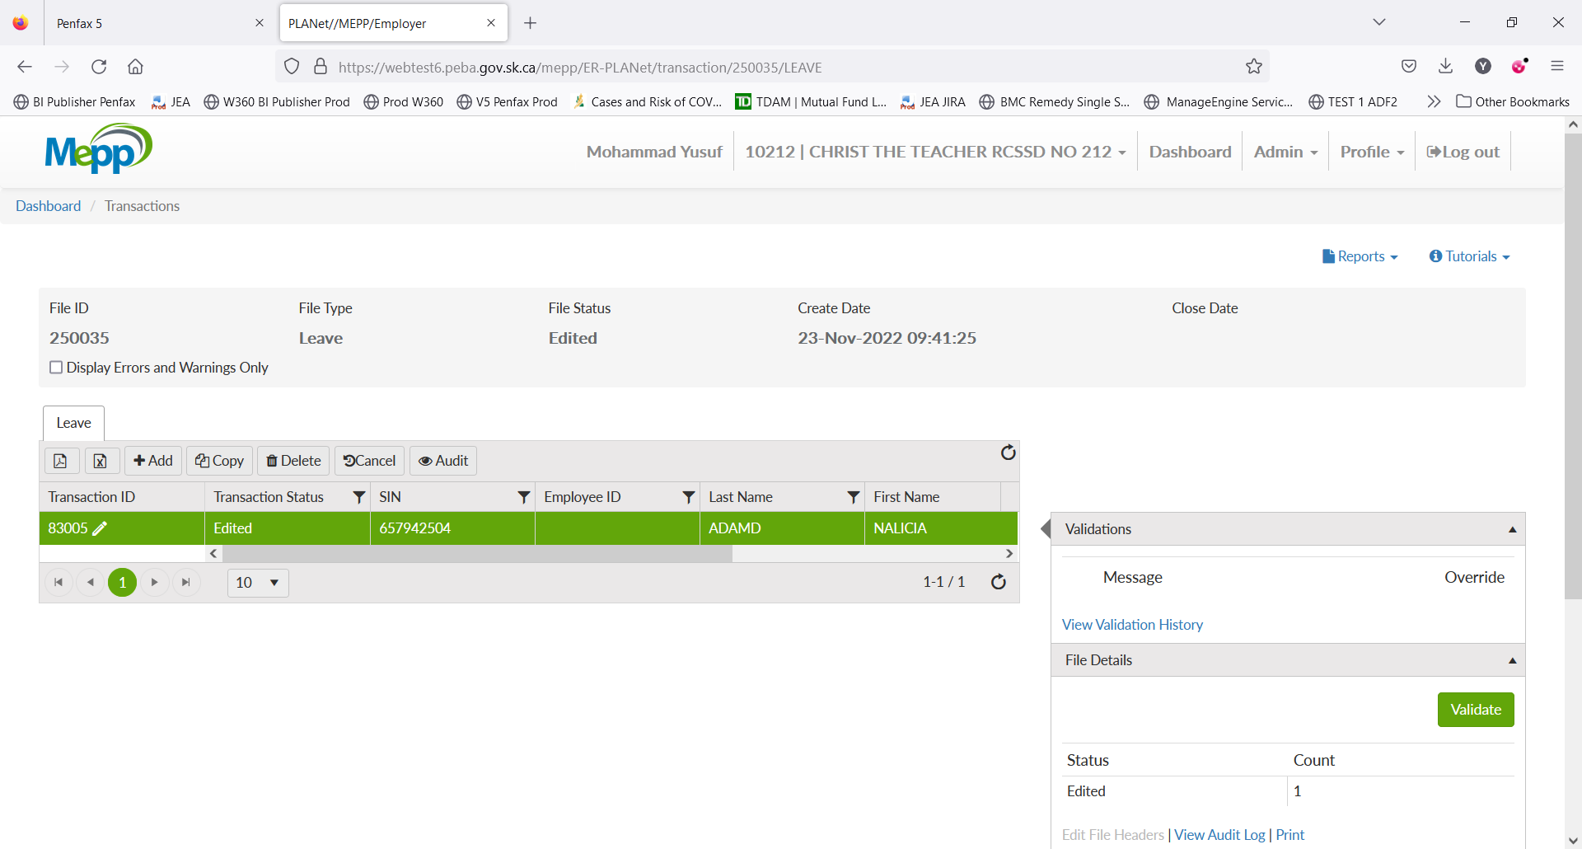

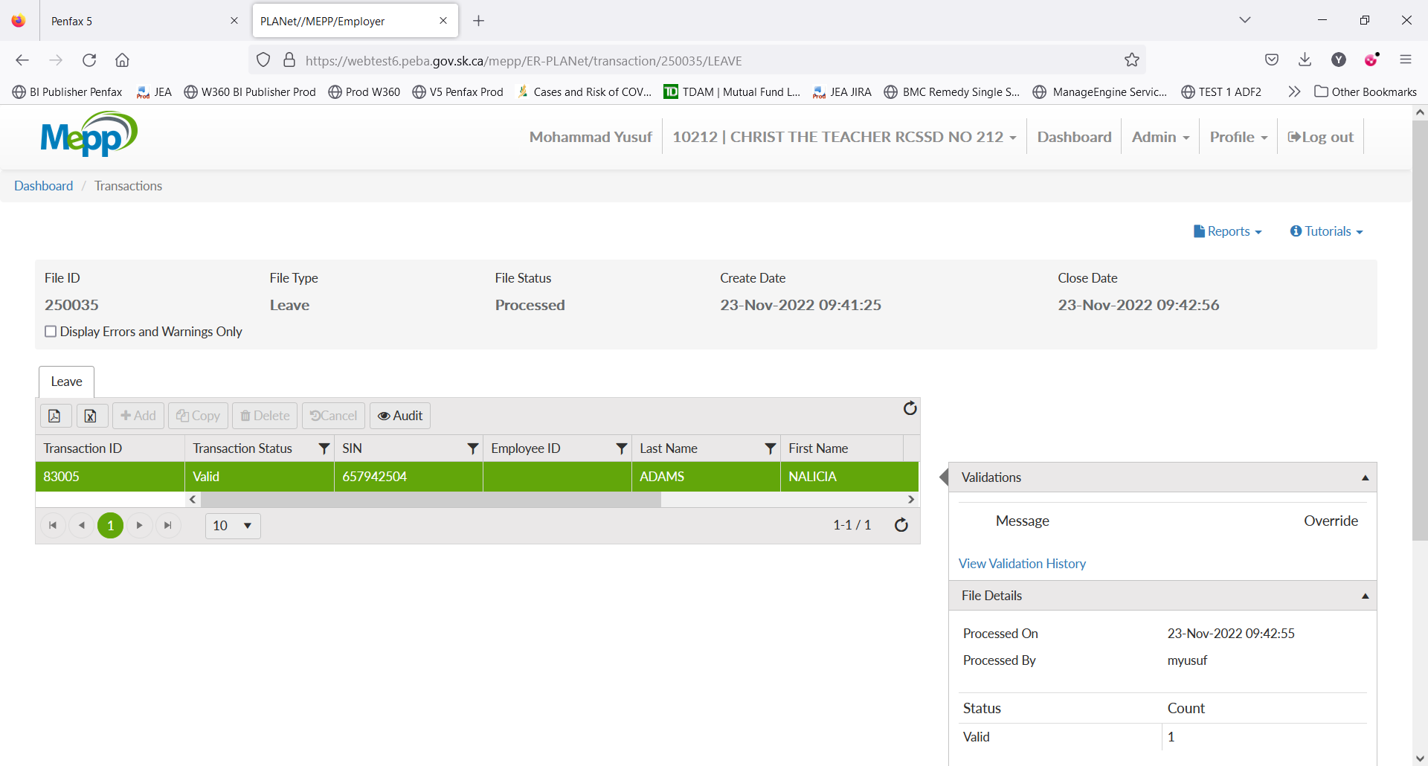

Validate the details entered. Process the Leave in DCT

Once processed, login into the penfax application.

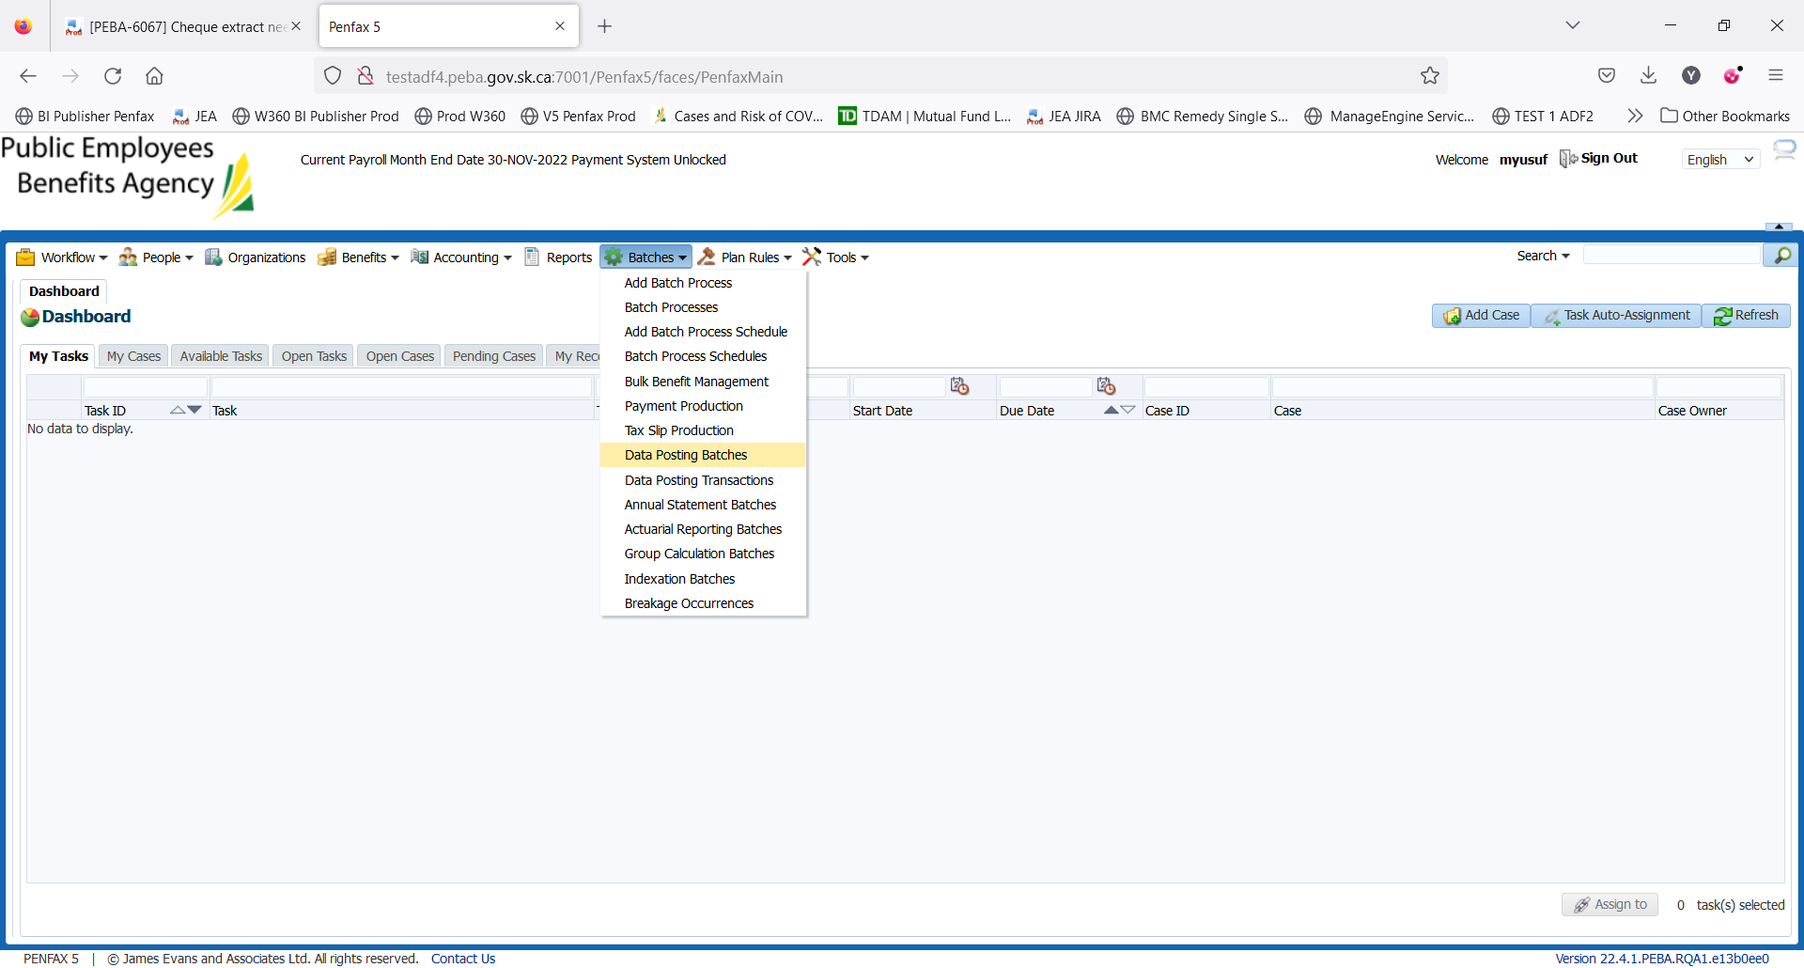

Batches-> Data Posting Batches

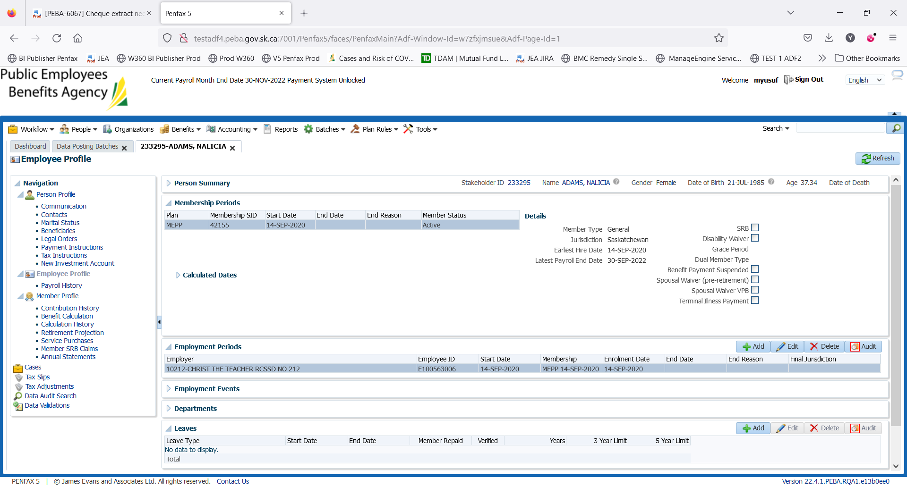

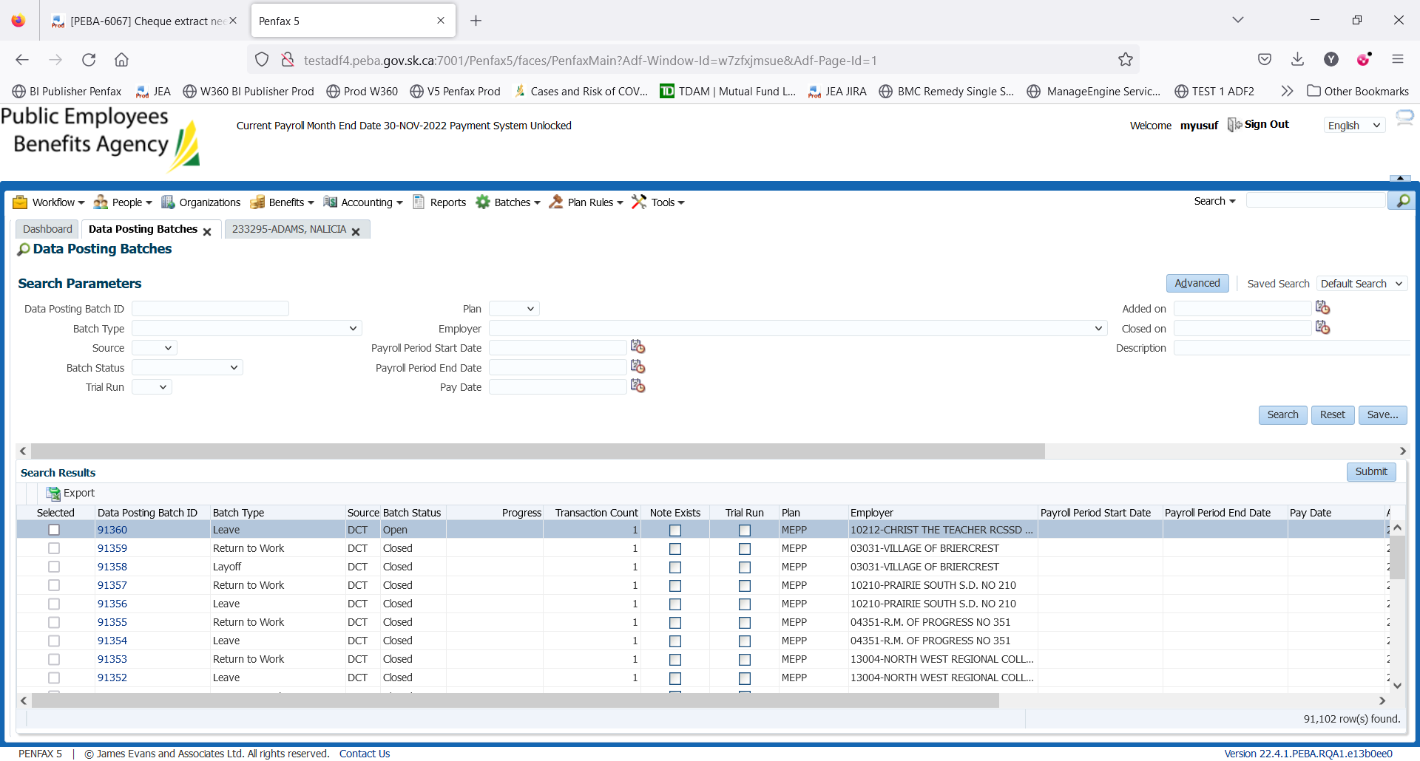

Process the latest Open batch. Select the Data posting batch ID

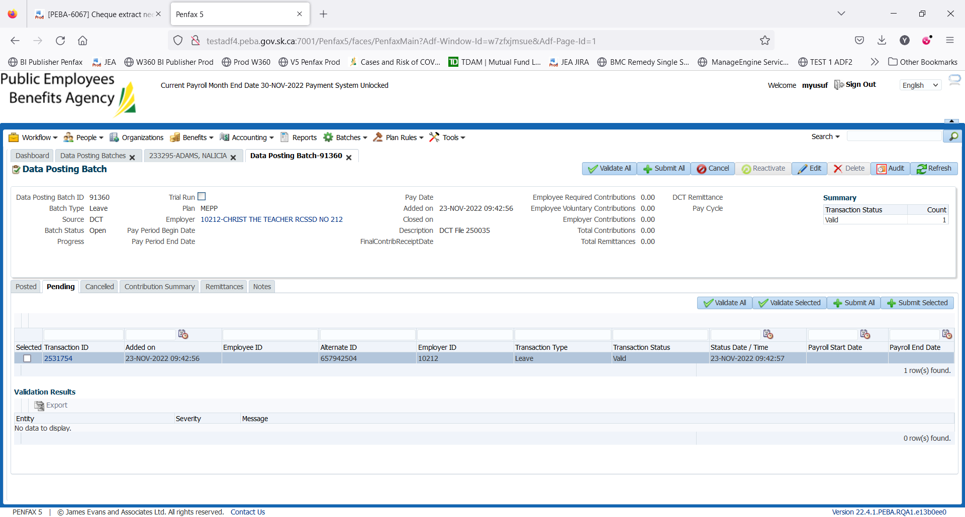

Validate it and then click on Submit All

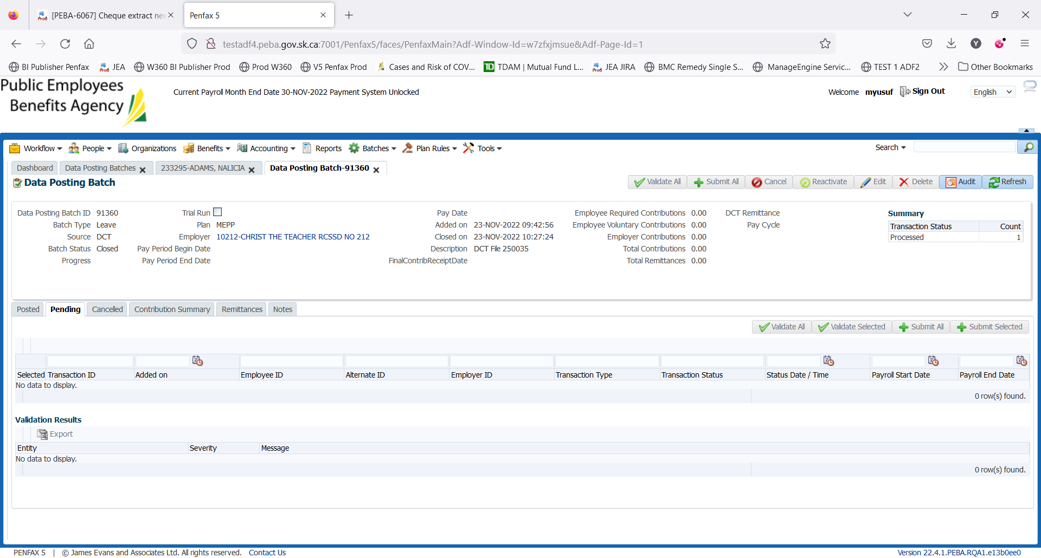

Leave is added to the members profile

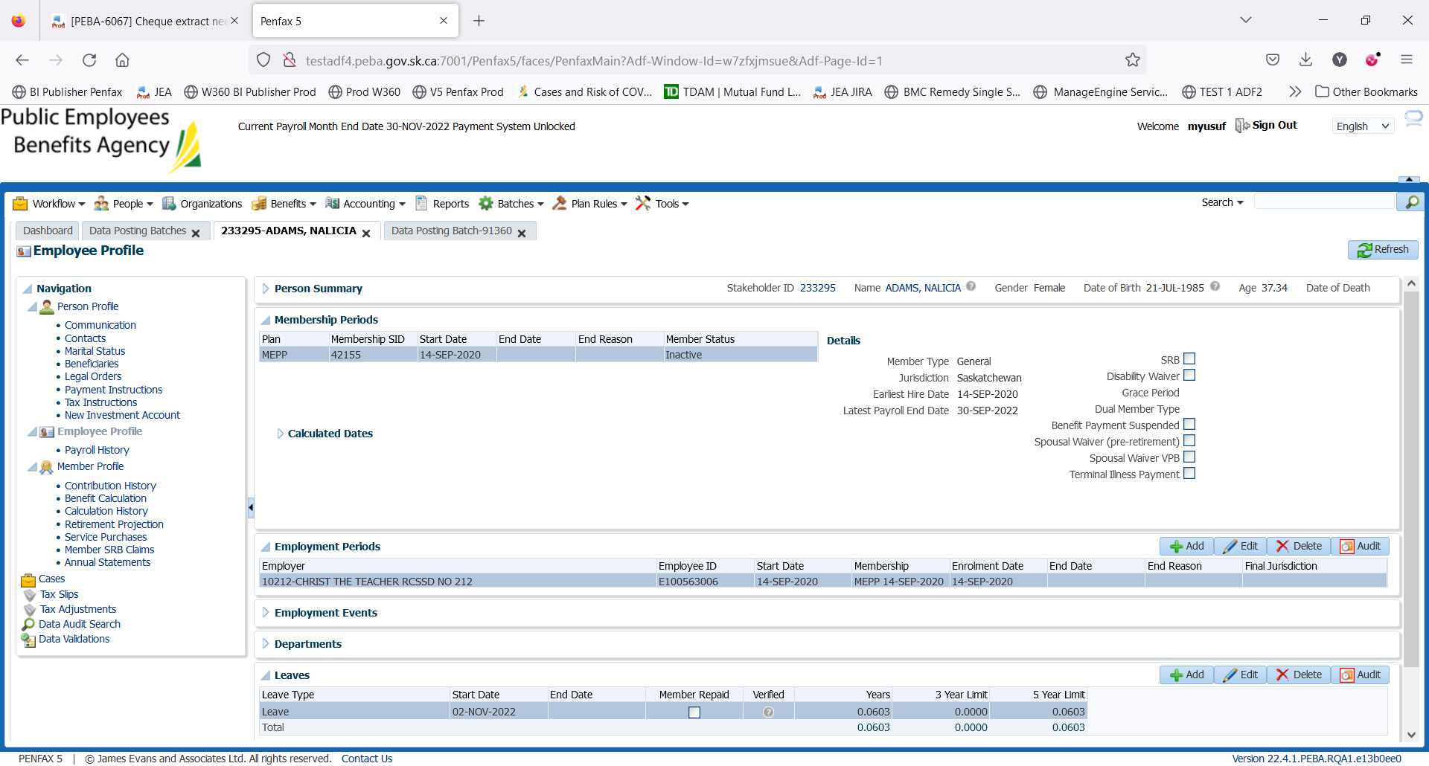

For updating the Leave status

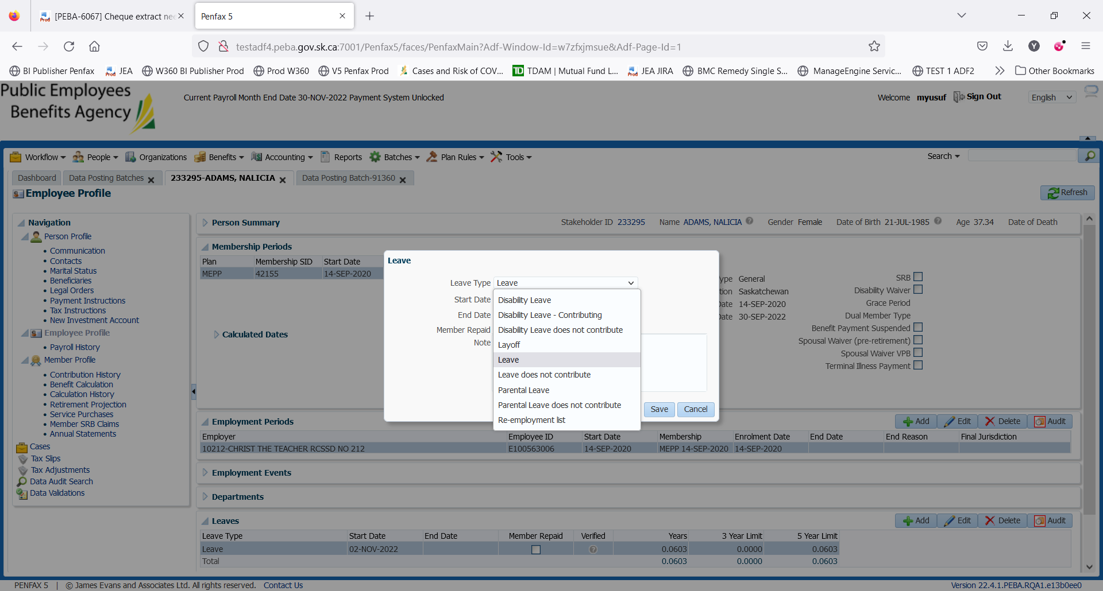

Select the Leave and click on Edit button beside it

Pop up window will open as above.

Select the Leave Type to Disability from drop down

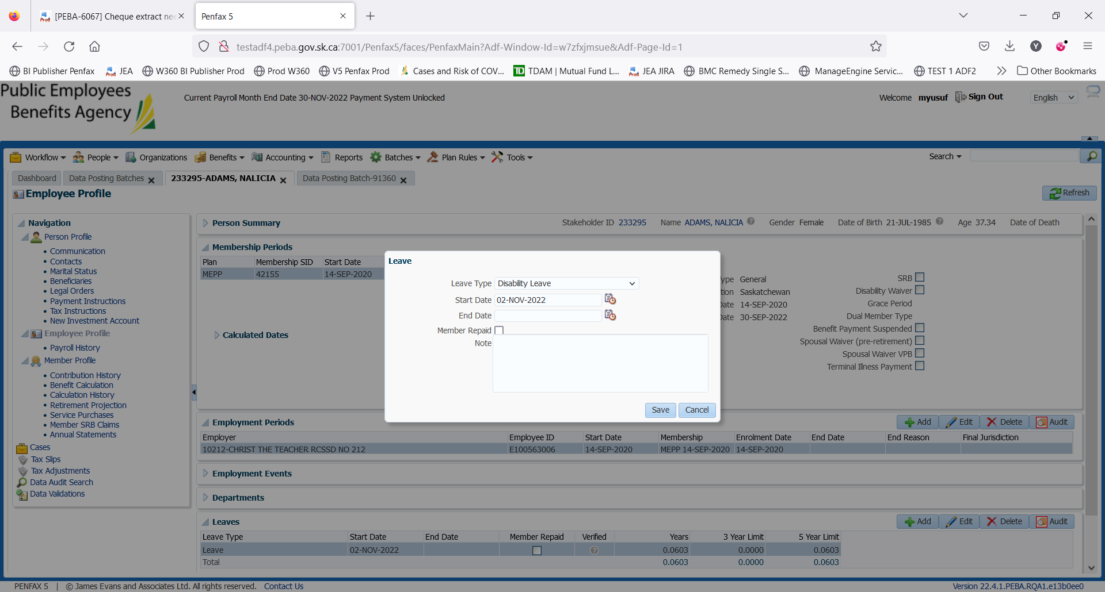

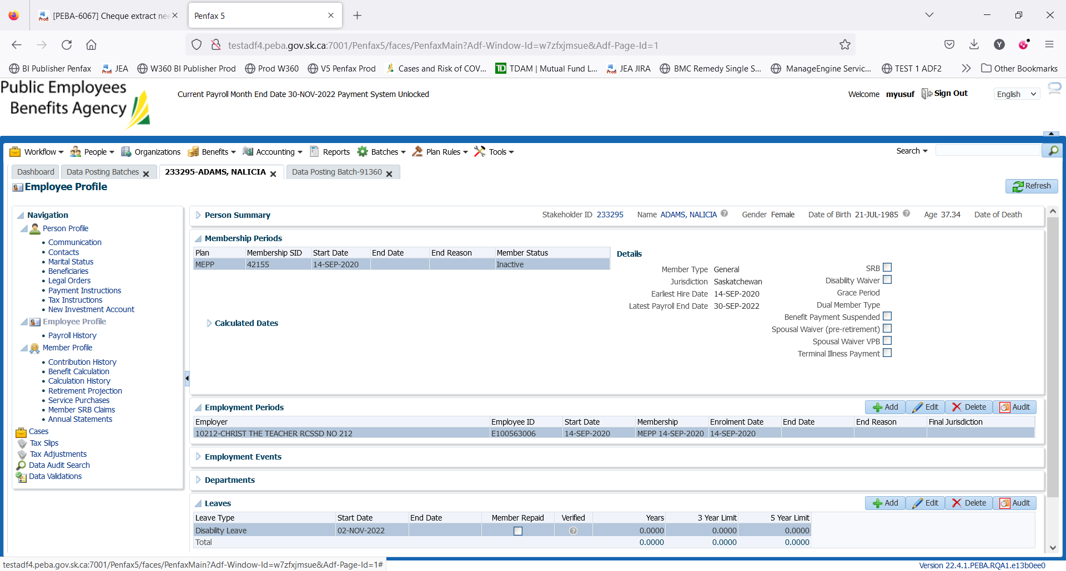

Click on save

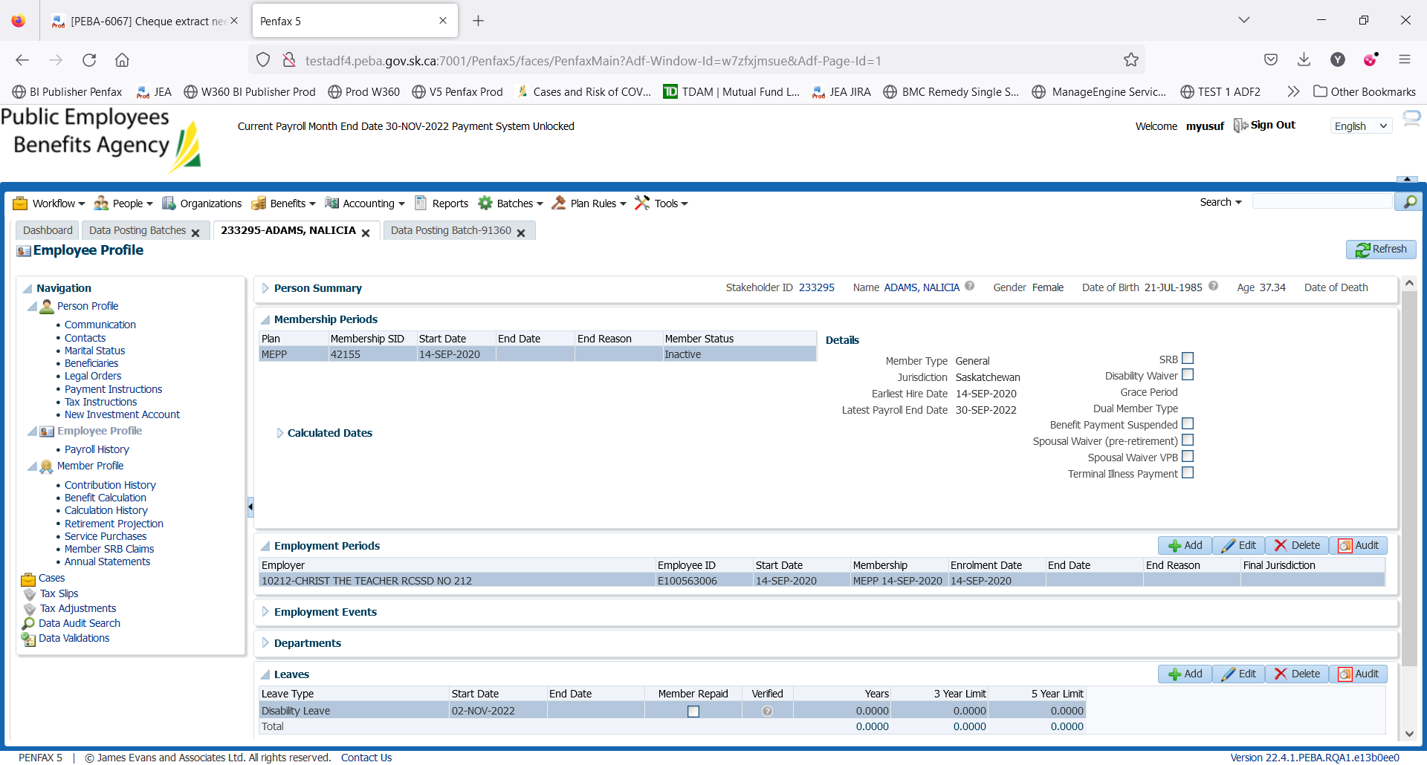

Leave is updated to Disability